**Dylan Jadeja**

1. **PERSONAL**

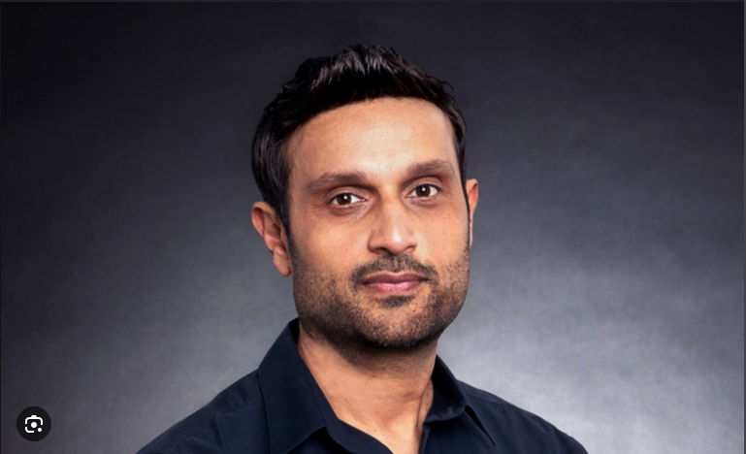 [1]

**A Through C:** Birth date and Social Security Number were not found for Dylan Jadeja during this investigation

**D. CURRENT ADDRESS:**

Dylan Jadeja resides in Los Angeles, California. No purchase history or data was found during this investigation.

**E. FORMER ADDRESSES:**

Dylan Jadeja was a former resident of Ontario, Canada.

**F. FAMILY MEMBER NAMES AND RELATIONSHIP:** No family data was found during this investigation.

**G. EMAIL ADDRESSES**

No email address was found during this investigation.

**E. SOCIAL MEDIA ADDRESSES**

The following social media handles are affiliated to Dylan Jadeja. *See MEDIA for specific content.*

* Facebook: Not Found
* LinkedIn: linkedin.com/in/adjadeja

Twitter: @riotjeet

* Instagram: Not Found
* Etc.

**ASSETS/LIABILITIES**

**I. PROPERTY**

Based on the available information, Dylan Jadeja does not appear to own any properties in his name.

Previous unverified addresses:

* Los Angeles, California (specific address not provided)

**VEHICLES**

No information available about vehicles registered to Dylan Jadeja.

**J. BUSINESS OWNERSHIP**

The following active business was located listing Dylan Jadeja as a full or partial owner:

Riot Games, Inc.

Chief Executive Officer

12333 W Olympic Blvd, Los Angeles, CA 90064

Incorporation date not provided

**PROFESSIONAL DEVELOPMENT**

**K. EDUCATION HISTORY**

According to **Dylan Jadeja** Likedin social media profile, he attended Ivey Business School at Western University and received an HBA in 1998.

He also attended Harvard Business School and received an MBA in 2004.

Credentials were unable to be verified, without a signed release.

1. **CERTIFICATION OR TRAINING**

**None to report.**

**PROFESSIONAL LICENSES AND DISCIPLINARY ACTION**

**No professional Licenses and or Disciplinary Actions were found during this investigation**

**EMPLOYMENT**

The following current and prior employers were located for Dylan Jadeja. Most of these positions were/were not able to be verified.

*Currently*

* Riot Games Inc. Chief Executive Officer May 2023 to Present
* President October 2017 to May 2023
* Chief Financial Officer and Chief Operating Officer 2011 to October 2017

*Historical*

* *Goldman Sachs Vice President August 2004 to August 2011*
* *A.T. Kearney Senior Associate September 1998 to June 2002*

1. **LEGAL**

**LITIGATION**

The search encompassed combined United States District case law file containing all case law from United States District Courts for all 50 States from 1789 to current, the District of Columbia, the District Court for Puerto Rico, the District Court for the Virgin Islands, the District Court for Guam, the District Court for the Mariana Islands, the Court of International Trade from November 1980, the Judicial Panel on Multi-District Litigation from 1968, the Special Court, and the Regional Rail Reorganization Act of 1973. **No litigation was located for**

**Dylan Jadeja.**

1. **CRIMINAL AND SEX OFFENDER REGISTERY**

**No litigation was located for Dylan Jadeja.**

**Search Engines & OSINT Tools**

* Google Advanced Search – (https://www.google.com/advanced_search)
* Bing – (<https://www.bing.com>)
* DuckDuckGo – (<https://www.duckduckgo.com>)
* Yandex – (<https://www.yandex.com>)

**Business & Corporate Records**

* Open Corporates – (<https://opencorporates.com>)
* SEC EDGAR Database – (https://www.sec.gov/edgar.shtml)
* California Secretary of State Business Search – (https://bizfileonline.sos.ca.gov/search/business)
* Better Business Bureau (BBB) – (<https://www.bbb.org>)
* Glassdoor – (<https://www.glassdoor.com>)
* Crunchbase – (<https://www.crunchbase.com>)

**Real Estate & Property Records**

* Zillow – (<https://www.zillow.com>)
* Redfin – (<https://www.redfin.com>)
* Realtor.com – (<https://www.realtor.com>)
* Los Angeles County Assessor Portal – (<https://assessor.lacounty.gov/>)
* Los Angeles County Property Assessment Inquiry – (<https://portal.assessor.lacounty.gov/>)
* Property Shark – (<https://www.propertyshark.com>)

**Employment & Professional Background**

* LinkedIn – (<https://www.linkedin.com>)
* Wayback Machine (Internet Archive) – (<https://web.archive.org>)
* ZoomInfo – (<https://www.zoominfo.com>)

**Legal & Litigation Records**

* Justia – (<https://www.justia.com>)
* CourtListener – (<https://www.courtlistener.com>)
* PACER (via RECAP Extension) – (<https://www.courtlistener.com/recap/>)
* FindLaw – (<https://www.findlaw.com>)

**Public Records Databases**

* The Wayback Machine – (<https://web.archive.org>)
* FamilyTreeNow – (<https://www.familytreenow.com>)
* FastPeopleSearch – (<https://www.fastpeoplesearch.com>)
* TruePeopleSearch – (<https://www.truepeoplesearch.com>)
* Whitepages (Free Version) – (<https://www.whitepages.com>)
* VoterRecords.com – (<https://www.voterrecords.com>)

**News & Media Archives**

* Google News Archive – (<https://news.google.com>)
* ProPublica – (<https://www.propublica.org>)
* The Smoking Gun – (<https://www.thesmokinggun.com>)
* MuckRock – (<https://www.muckrock.com>)

**Search Engines (Google, Bing, DuckDuckGo, Yandex)**

"Dylan Jadeja" site:google.com OR site:bing.com OR site:duckduckgo.com OR site:yandex.com

**Business & Corporate Records**

* **OpenCorporates**

"Dylan Jadeja" site:opencorporates.com

* **SEC EDGAR Database**

"Dylan Jadeja" site:sec.gov

* **California Secretary of State Business Search**

"Dylan Jadeja" site:sos.ca.gov

* **Better Business Bureau (BBB)**

"Dylan Jadeja" site:bbb.org

* **Crunchbase**

"Dylan Jadeja" site:crunchbase.com

**Professional Background**

* **LinkedIn**

"Dylan Jadeja" site:linkedin.com

* **Wayback Machine (Internet Archive)**

"Dylan Jadeja" site:web.archive.org

* **ZoomInfo**

"Dylan Jadeja" site:zoominfo.com

**Legal & Litigation Records**

* **Justia**

"Dylan Jadeja" site:justia.com

* **CourtListener**

"Dylan Jadeja" site:courtlistener.com

* **PACER (via RECAP Extension)**

"Dylan Jadeja" site:pacermonitor.com

**Public Records Databases**

* **FamilyTreeNow**

"Dylan Jadeja" site:familytreenow.com

* **TruePeopleSearch**

"Dylan Jadeja" site:truepeoplesearch.com

* **Whitepages (Free Version)**

"Dylan Jadeja" site:whitepages.com

* **VoterRecords.com**

"Dylan Jadeja" site:voterrecords.com

**Property Records**

* **Zillow**

"Dylan Jadeja" site:zillow.com

* **Redfin**

"Dylan Jadeja" site:redfin.com

* **Realtor.com**

"Dylan Jadeja" site:realtor.com

* **PropertyShark**

"Dylan Jadeja" site:propertyshark.com

* **Los Angeles County Assessor**

"Dylan Jadeja" site:assessor.lacounty.gov

**Advanced Boolean Search (General Search)**

"Dylan Jadeja" AND ("company" OR "business" OR "CEO" OR "executive") AND ("lawsuit" OR "court" OR "legal") AND ("real estate" OR "property" OR "assets")

* 1. **MEDIA, SOCIAL NETWORKS AND OPEN SOURCES**

***Traditional Media – News and Literature***

In researching aggregator databases of news, thousands of international newspapers, magazines, transcripts, and blogs, for results regarding Dylan Jadeja, the following recent results were located.

LoL players rally for Riot CEO’s removal—and thousands have already signed a petition to boot him out of the company, Dot Esports, Rihit Banerjee, February 25, 2205

A growing movement within the League of Legends community is demanding the removal of Riot Games CEO Dylan Jadeja, with thousands of players signing a petition calling for his departure. It started as frustration over the game’s recent direction, but now has fans pushing for accountability at the highest levels.

# The immediate removal of Riot Games CEO Dylan Jadeja, Sam G, February 2025

For years, League of Legends has been one of the biggest and most beloved games in the world. But under the leadership of Dylan Jadeja the game has been going downhill at an unprecedented rate. Riot Games has made decision after decision that prioritizes profits over player experience, and the community is tired of being ignored and treated like complete idiots who they only see as numbers to get money from. Yes a lot of what’s happening can be pinpointed to the previous CEO’s (Nicolo) mishandling of the company’s money, but that doesn’t excuse how they are proceeding from that situation. This doesn’t feel like it’s the way to handle a company that needs more money, especially if you want to keep a lot of your players happy and on the game for as long as possible. It’s a short term profit for a long term dig in the grave that only benefits its CEO.

***Social Networks***

The following social media profile pages were located on Dylan Jadeja. The following are the key items captured from the specific network sites, with the pages themselves appended to this report.

Facebook:

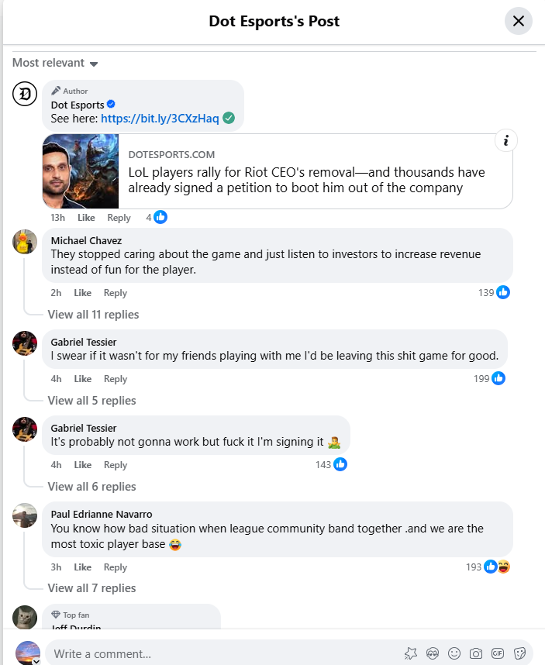

LinkedIn:.

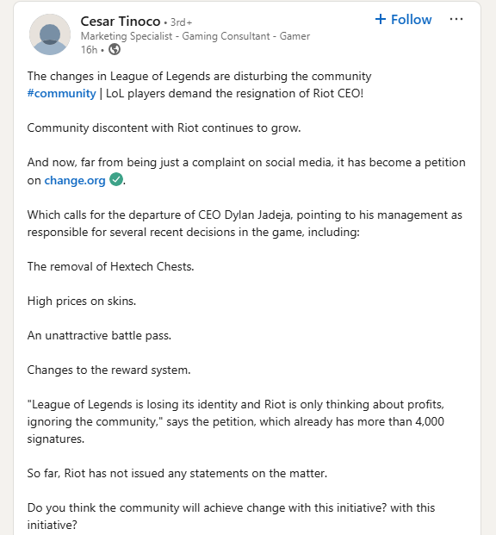

Twitter (X) :



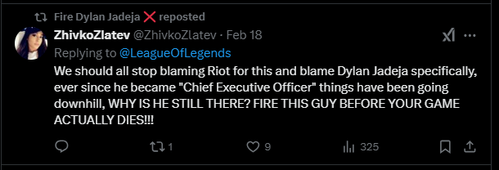

**Exhibits**

The following exhibits are screen captures, analyst’s charts, diagrams and content gathered while conducting this investigation.

1. **Exhibit: Petition for Dylan Jadeja's Resignation**
   * "Demand for Dylan Jadeja's Resignation as CEO of Riot Games for Damaging Long-Standing Gameplay"

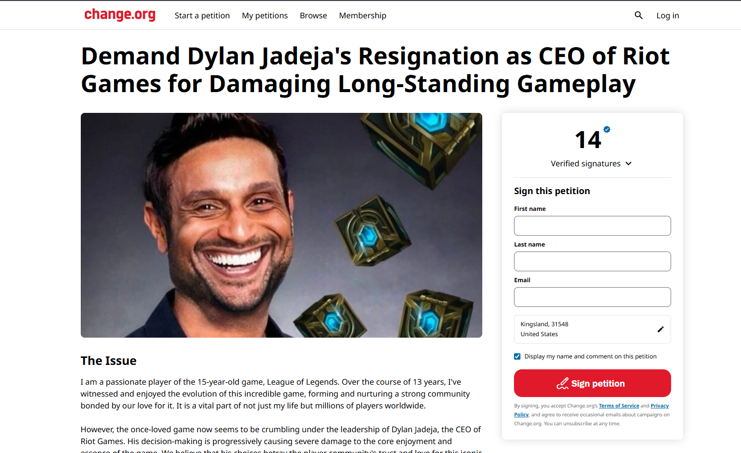

1. **Exhibit: News Article on Player Boycott Calls**

* "League of Legends Players Call for Boycott Over Recent Changes"



1. **Exhibit: Riot Games Backlash Report**

* "Riot Games Faces Backlash After Mass Layoffs and Monetization Changes"

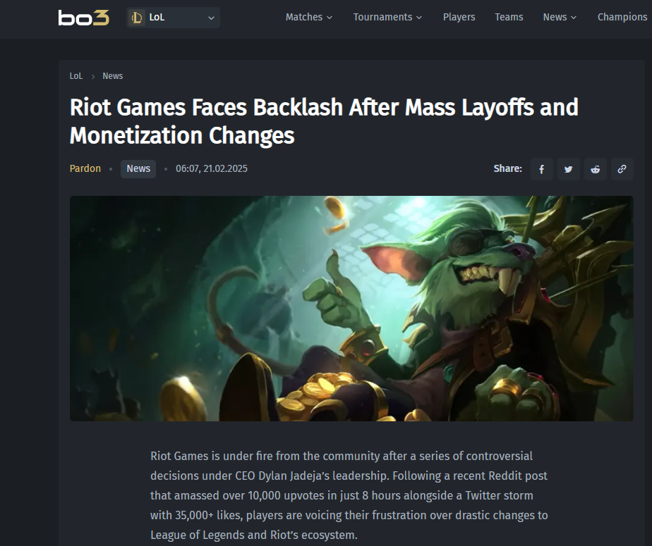

1. **Exhibit: Riot Games Backlash Report**

* "Riot Games Faces Backlash After Mass Layoffs and Monetization Changes"

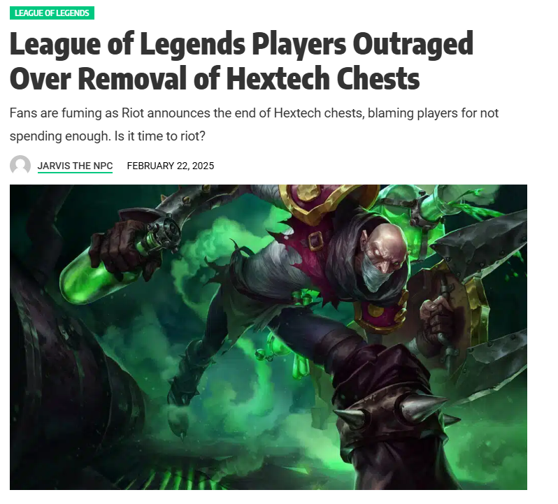

1. **Exhibit: Riot Games Backlash Report**

* "Riot Games Faces Backlash After Mass Layoffs and Monetization Changes"

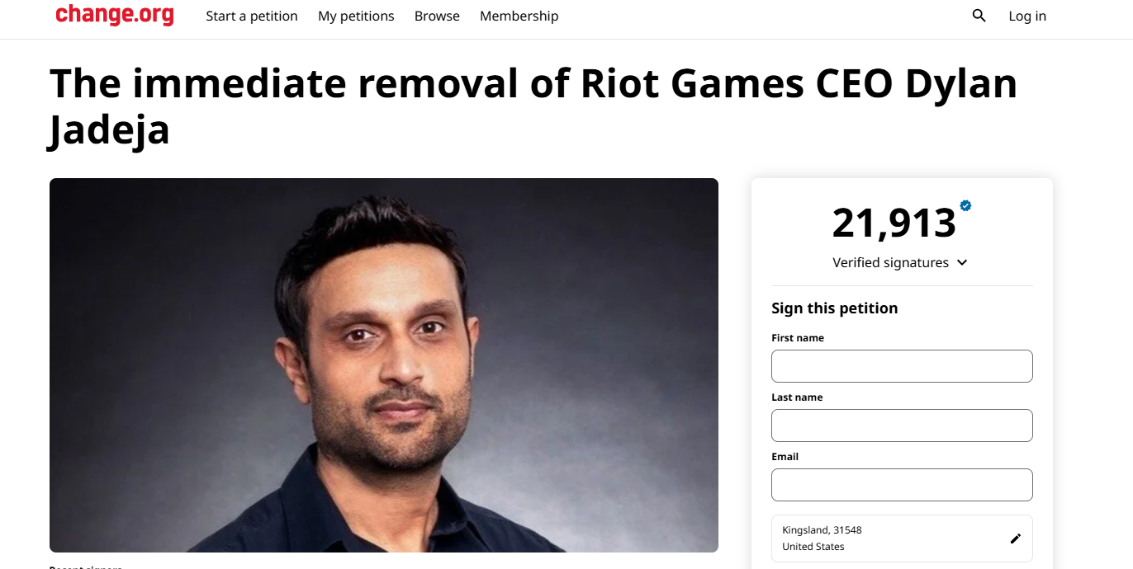

1. **Exhibit: Riot Games Backlash Report**

* "Riot Games Faces Backlash After Mass Layoffs and Monetization Changes"

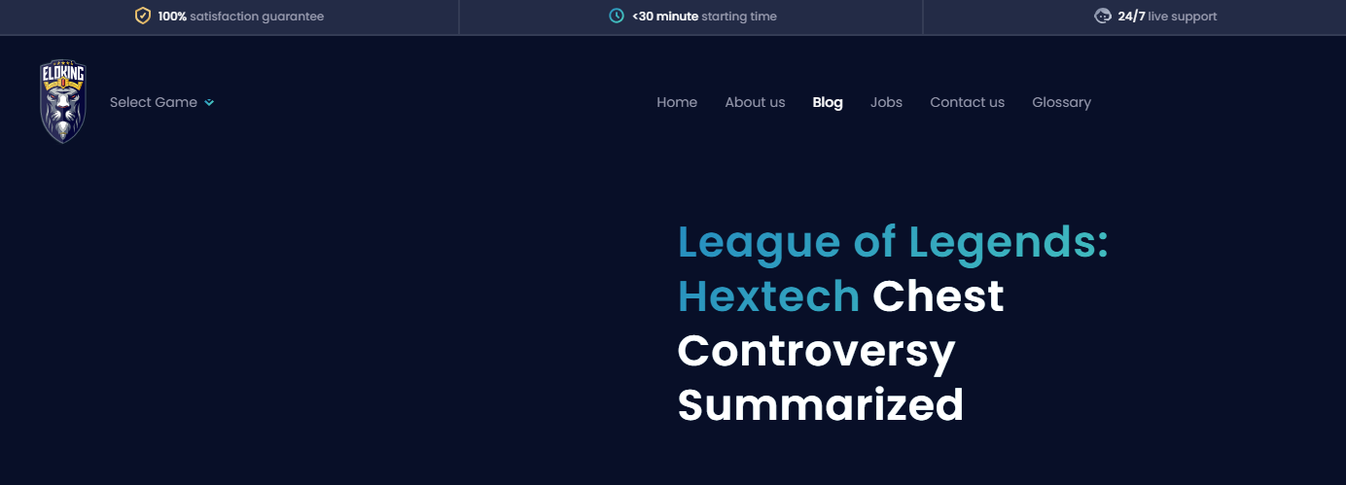



1. Photo acquired from [LinkedIn/Facebook]